Contents

Weekly Changes April 17, 2021 1

Note 1

Application 1

Appraisal 1

Assessment 2

Personal Property 3

BOE 4

Reports 4

Review Sheet 4

926 and 926-P 5

Top Assessment Report 5

VI Count by Subdivision 5

# Weekly Changes April 17, 2021 (Manual Updated 06/30/2021)

## Note

* When printing the 916 (Add HS Reimbursement) you may want to change to the tax roll dataset to report this based on what the exemptions were at the time of taxroll.

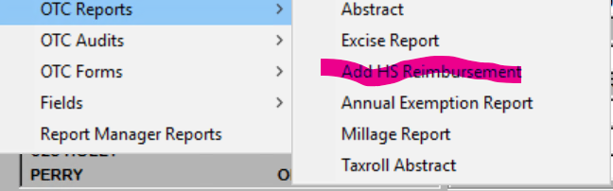

## Application

* When requesting the help files in the assessment form you will be taken to help on the tab you are on.
* When in map analyzer and displaying on second monitor there were times that remnants of the screen would display. This have been corrected where this should not occur.

### Appraisal

* While splitting parcels if outbuildings were moved to the new parcel, they would stay on the original site plan. This has changed where they will follow the account they were moved to. In the case of the combine this does not occur as we don’t have the relationship between the buildings of the two accounts and this may lead to confusion. In the combine the outbuildings would need to be drawn on the site plan. (Added to the manual 04/18/2021)

#### Outbuildings

* On the outbuildings form the appraisal zone will be on the form
* The view edit log was displaying all records for the appraisal record. This will now show edits on the outbuilding.

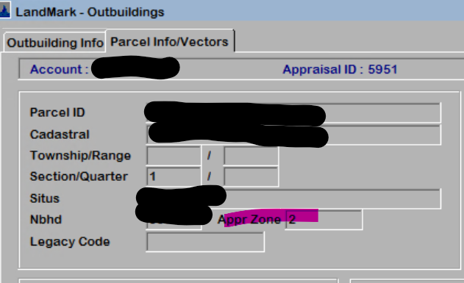

#### Miscellaneous Improvements

* On the miscellaneous improvements form the appraisal zone will be on the form
* The view edit log was displaying all records for the appraisal record. This will now show edits on the miscellaneous improvement.

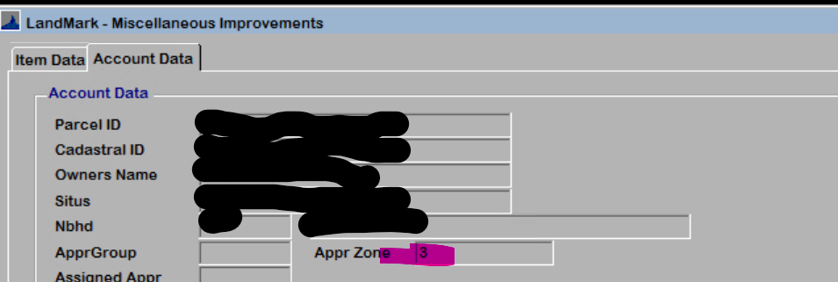

### Assessment

* Capped amounts are added to the appraisal summary. The current value represents what the capped value is currently (may not be currently capped). The Appraisal capped amount represents what the capped value would be if the appraisal value would be read in. The fair cash change column is the different between the current cap value and the appraisal capped value

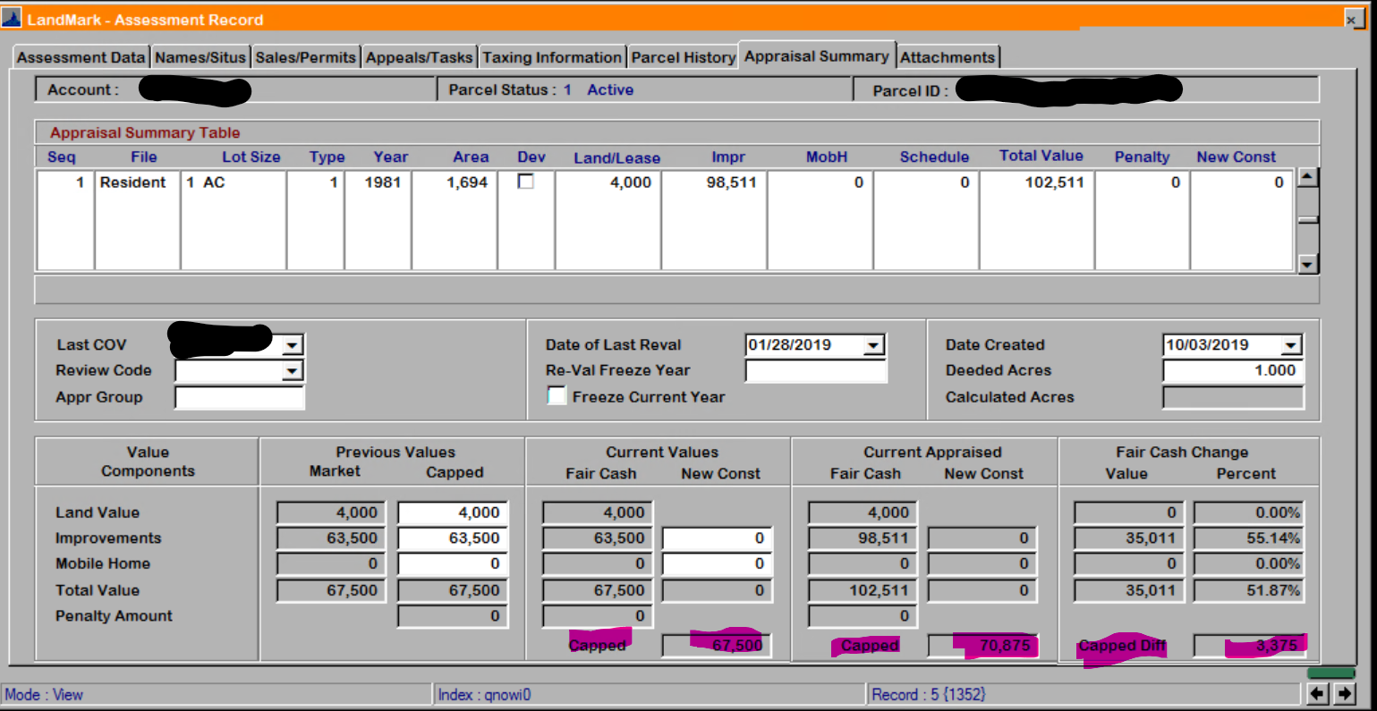

* If you select to view the sale and there is not a sale record you will be informed of this. Previously this would take you to an unrelated record. This is occurring on converted records where the information was in AA but there was not a sale record linked to it.

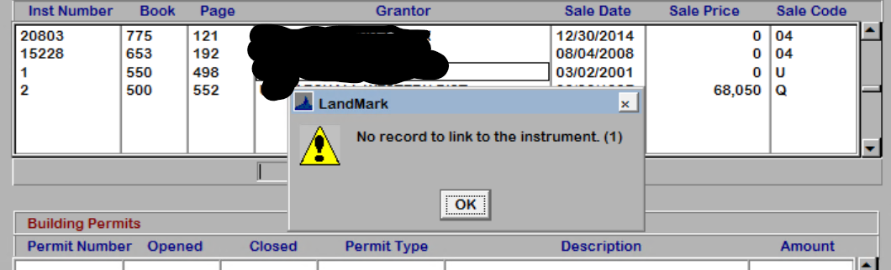

* When editing legal description through View – Edit Legal the “&”, “?” would be removed when saved. This has been corrected.

### Personal Property

* When importing in TASC schedule there is the option to code the account as a notice is required.

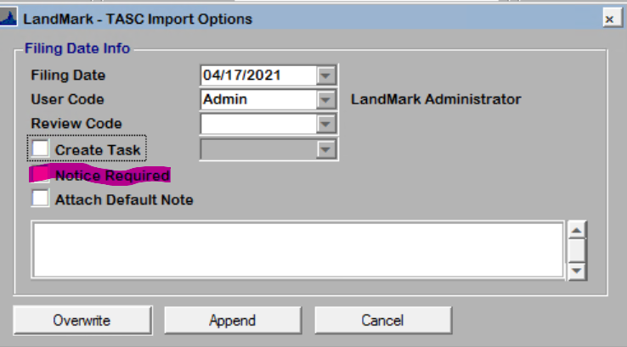

* When trying to delete the personal property appraisal record you will get the message that the record must be inactive.

### BOE

* Can now save documents to the BOE records.

## Reports

### Review Sheet

* On the review sheet there is the option to include building permits and open tasks for an account. These will print above the user comments section. By default (if no parameter is included these will not print)
* There is the option for the additional photos to not print. By default, these will print.

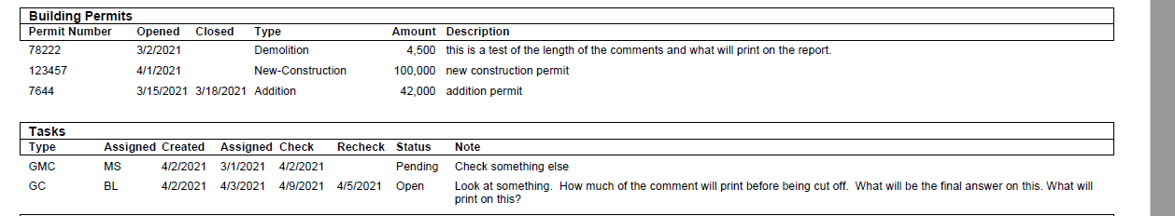

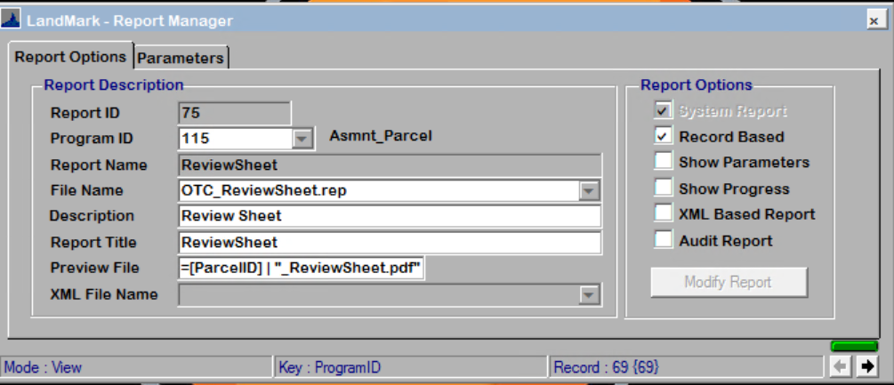

The record may not be in the list to begin with. To add use the drop down list.

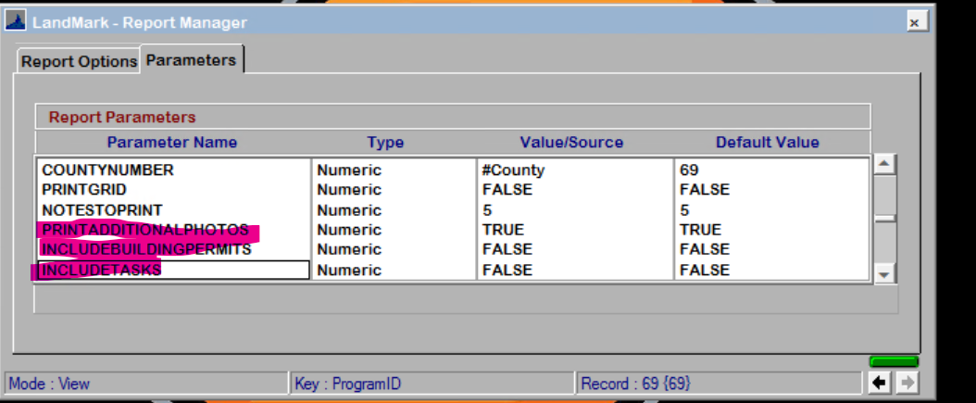

### 926 and 926-P

* The Notice-Text notes will print on the report.
  + An addition has been added to both reports. For the notes to print the date of the notes must match the working year in the county information table. This is so the same note does not continue to print on the report year after year.

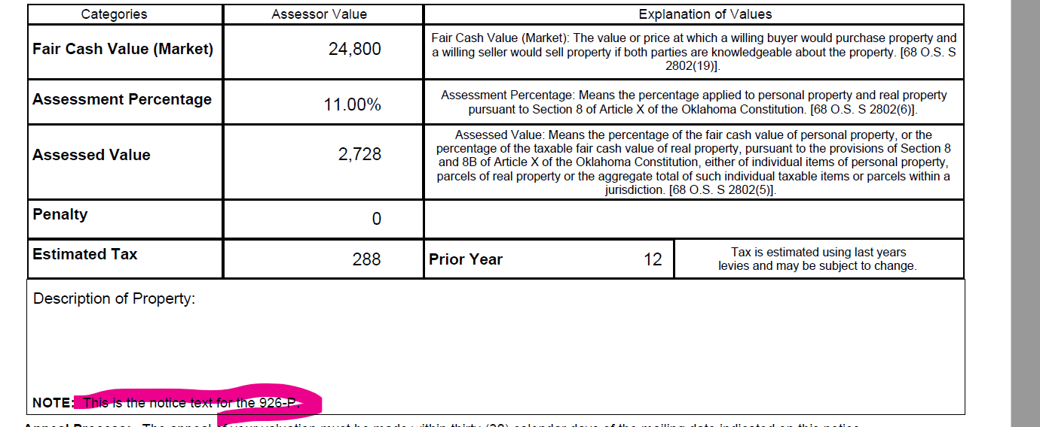

### Top Assessment Report

* The top assessment report was including amount from the real property on public service accounts. This has been corrected.

### VI Count by Subdivision

* There is a new report that will print separate the counts on the VI report based on subdivision (first 4 of parcel)

