Contents

Weekly Changes September 19, 2022 1

Assessment 1

Personal Property 2

Reports 3

Review Sheet 3

926P 4

Sale Qualification 4

Sales 4

Miscellaneous Costs 5

County Information / Website Photos 6

Browsing 7

NBHD and Subdivision 7

# Weekly Changes September 19, 2022

## Assessment

* Aug 29th On splits, subdivide, and combines the value change comment was not being saved to the value record. This will be saved now.

* + Child account will have the same message.

* Aug 29th If an ownership is added for an exempt owner a value change record will be created.
* Sep 19th When in edit mode you won’t be able to right click to delete an exemption.
* Sep 19th When entering a frozen year the value calculated will taken into account the homestead exemption that should be added to the account. When process pending accounts and the remove year is the year of the new year the frozen value will be removed. This is because if the account is frozen again the value calculation will occur instead of having to enter it.

## Personal Property

* Aug 29th There is an addition where if the filing date is changed and the rate will be change you will be asked if you want to change the rate.  Before if there was a penalty percent there was no change done.  If going from 0% to 10 or 20% there will not be this information as there is a configuration option for this.

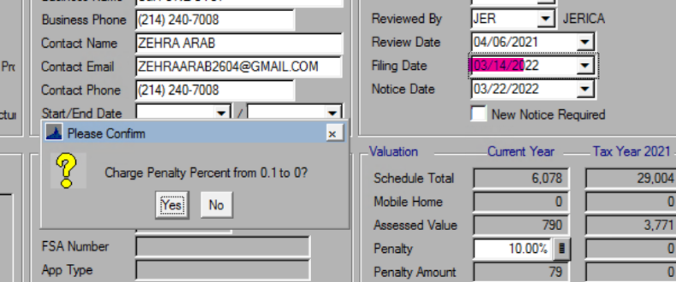

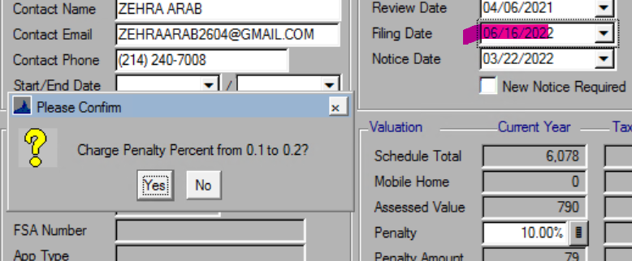

* + There is an option for a personal property pop up.  This will let you know if interest will be charged. Some counties are using this around the filing deadlines as the postmarks may be coming in before and after the filing dates. This has been in place since March.

* + If a date is entered that will charge penalty. If you don’t the filing date will be changed, and no penalty calculated at that point.

## Reports

### Review Sheet

* Sep 19th The review sheet now has a spot to enter the fire sprinkled area.

### 926P

* Sep 19th The 926P can be printed from a dataset now.

## Sale Qualification

* Sep 19th On the sale qualification table there is a required note column. This will require a not on the sale if this qualification code is used. If code 21 has the description of Other then this will be checked. These qualification codes can be changed.

## Sales

* Aug 22nd If an invalid qualification code is entered you will receive a message and will be required to enter a valid code or clear the code.

* Sep 19th If the qualification code enters requires a note

You will receive this message if a code requires a note and one is not entered.

You will then be taken to the adj/qual code field. A note will need to be required. You can set up default notes in the sale adjustment table. (View – Adjustment Reasons in the sale file)

* Sep 19th In the OTC extract the qualification notes will be exported.

## Miscellaneous Costs

* Sep 19th With System and Locally defined codes you can use the cost factor to adjust the cost that are set up. Prior to this entering information for codes using this cost source had no effect. This will not have any effect on existing codes and the screen shot is just a sample I put together locally. If you make changes to the cost factor you will need to recalculate appraisal records that have the code that was modified.

## County Information / Website Photos

* Sep 19th On the county information form there is an option to only have the primary images on MapView. This is a placeholder right now where there won’t be any effect on the website as this is in the queue for development.

* + When complete if this is checked only the primary image and sketch/site plan will display on MapView (website).
  + To have an individual photo not display on MapView you can archive and image. This is available now. You will be able to mark a phot as IsPrivate and this will not display on MapView. The IsPrivate option will be functional on MapView at the same time the primary image option is available.

## Browsing

* Sep 19th General browsing has been made more consistent. You will be able to double click to select the record. If in the parcel file if the account is inactive the row will be red, pending active will be orange. In the appraisal file if the appraisal record is inactive the row will be red. Other table if the record is deleted the row will be red.

## NBHD and Subdivision

* Aug 22nd The drop downs for neighborhood and subdivision will be in alphabetical order by code vs how they were entered into the system.