Contents

Weekly Changes Oct 24,2024 1

Uncapped Value/New Construction 1

Assessment 1

Residential 2

Commercial File 2

General 3

Sales 3

# Weekly Changes Oct 24,2024

## Uncapped Value/New Construction

* Terminology has been updated changed from New Construction to Uncapped Value. All menu options/reports/etc have been updated to reflect this.

Assessment Appraisal

## Assessment

* When doing splits and combines there is now the option to copy the sale information to the created/combined accounts. This will not be checked by default. This will be seen on the sale/permits tab on the assessment form.

Split

Combines

* During subdivides you are now allowed to enter an alpha block number.
* The previous market value will be reflected based on what dataset you are in. Prior it displayed the previous market based on the last statements (parcel history) created.

* A new field is available to query in the assessment file on whether the property is Vacant or Improved. This does not display on the screen however this can be queried/exported. The extracted data file will have this field as well.

## Residential

* When moving a site improvement to a residential card you will be asked to save the improvement to the sketch or site plan. You may still need to move the improvements on the new account to change the relationships of the other items.

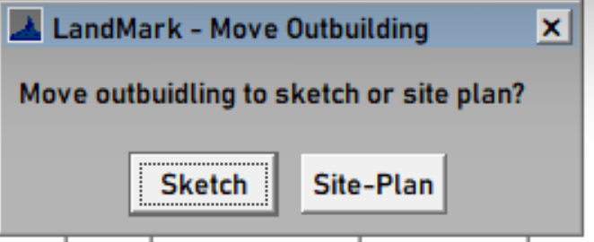

* When moving site improvements, the sketch and site plan on both appraisal records will be updated.
* When copying an edit log was not being placed on the account the outbuilding was being copied from.
* When surrendering the mobile home title, the value has always moved from the mobile home to improvement value. The uncapped value/new construction would not move from mobile home to building. This will occur now.

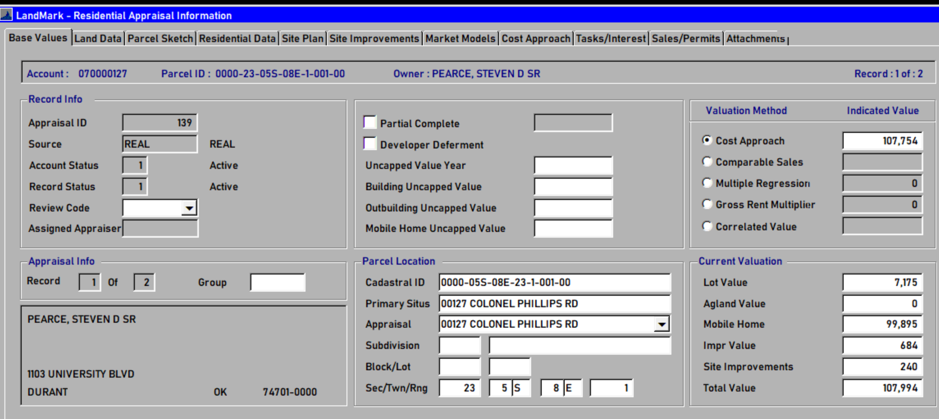

Surrender

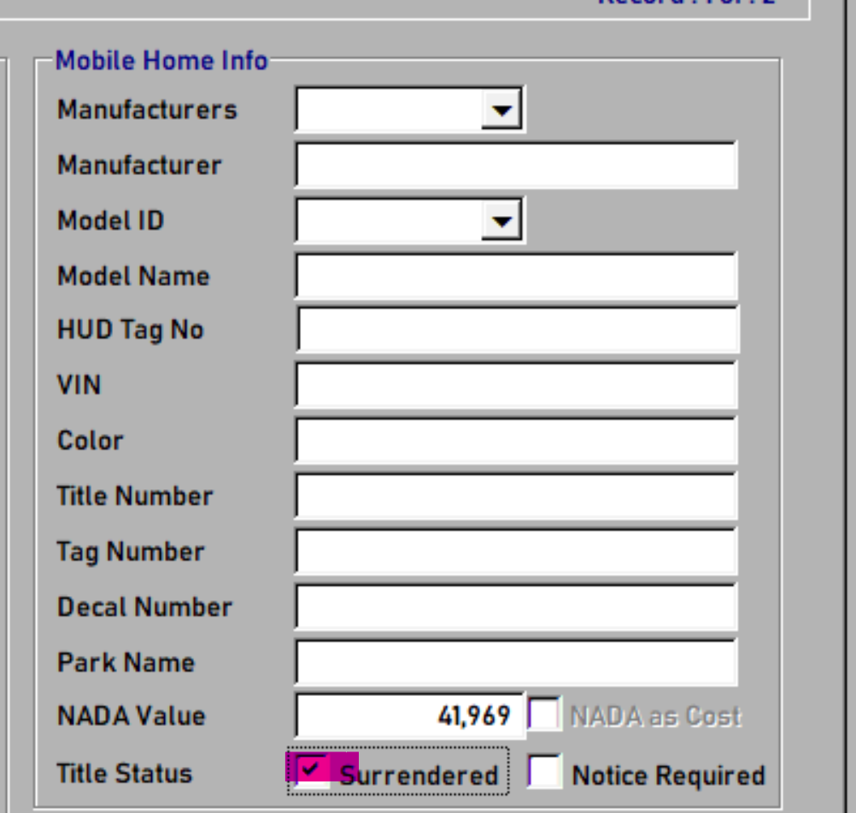

## Commercial File

* When moving a commercial building the miscellaneous improvements and modifiers will follow the building. Prior they were not.
* When copying an edit log was not being placed on the account the outbuilding was being copied from.
* The moving of a commercial building was not being tracked in the edit log.
* There is a new error check for cards that have a commercial building where there is not a number of stories entered.

## General

* When you attempt to delete a group level hot key you will be informed you can’t do this. The deletion of the group level

* Can open documents with the same name. Prior you could not open two documents at the same time. (COV for the 2024 and 2023 year)

## Sales

* Attaching documents in the sale file has been modified to run smoother.