Contents
Weekly Changes June 16, 2024 1
Most Files 1
Residential and Commercial File 1
Penalty 1
Reports 2

Weekly Changes June 16, 2024

Most Files
- There are fields to indicate if the record is active or deleted. This can be used to query active and deleted records. (Using deleted = 0 and deleted = 1 can continue to be used in the view expression.)

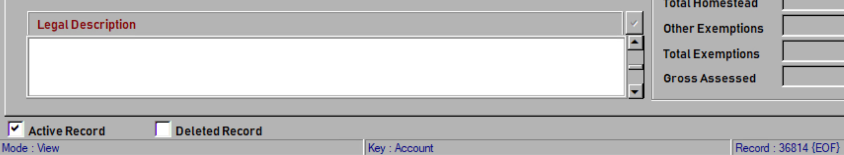

Residential and Commercial File
- On the land data tab information about neighborhood cost adjustments can be found.
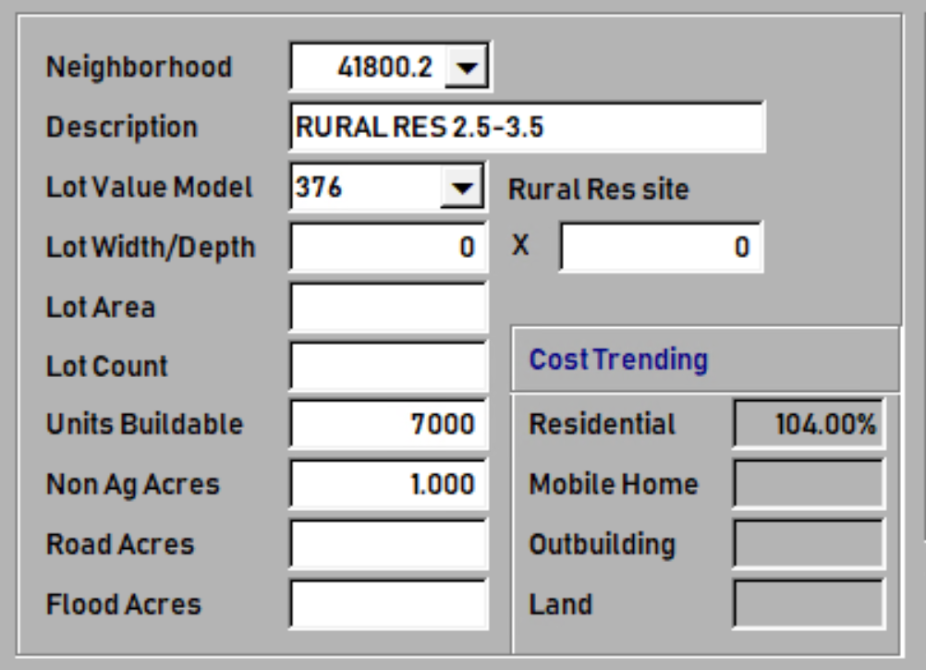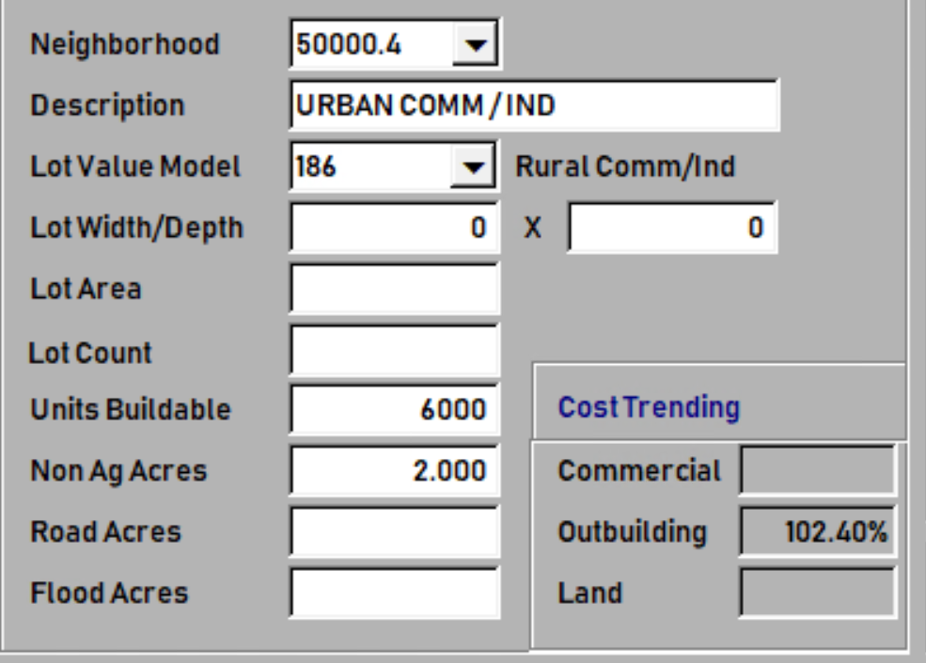

Penalty
- When making a change to the filing date that change the penalty the wording has been changed from Charge Penalty… to Change Penalty…
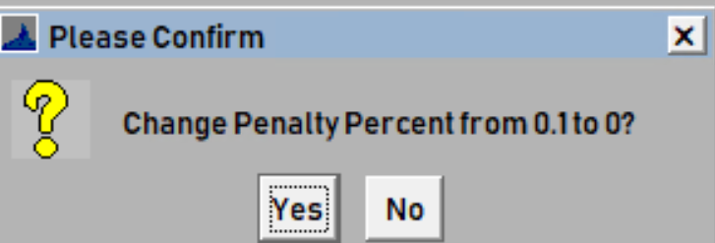

Reports
- The percent complete from the appraisal information will be on the review sheet.
