Contents

Weekly Changes July 23,2024 1

Assessment 1

Personal Property 1

Public Services 2

Appraisal Manual 2

Appraisal Zone 3

Task Types 3

Field Editor 3

Datasets 3

Reports 3

Review Sheet 3

DAV Report 4

DAV Report by Tax Area 5

Residential Sales Form 6

# Weekly Changes July 23,2024

## Assessment

* When reading in IOLL the IOLL value will be in the IOLL row (top row of values) vs building value.

## Personal Property

* You now have the option of copying the contact name, email, and phone to all personal property records with the same name id. Select Tools – Update Contact Inf
  + You will be asked to update the contact information.

* + Once completed you will be asked to open the file that will get information on which records were updated. There will be an edit record on each of the accounts updated.

* + If there are no additional records to update you will be informed of this.

## Public Services

* The email and business phone will be on the company and district records.

Company

District

## Appraisal Manual

* Can delete an appraisal manual record.

* + If the manual is in use, you will receive this message.

## Appraisal Zone

* You will not be able to delete and appraisal zone if it is in use.

## Task Types

* There is the option to flag a task type as private. These will not print on the review sheet.

## Field Editor

* When copying images if there is the text file that contains a note and whether the picture is primary will be copied to the processed folder.

## Datasets

* When opening the tax district file you would receive an error message. This message has been removed.

## Reports

### Review Sheet

* There is the option to specify the number of tasks to print on the review sheet and whether to highlight them.

* + The parameter INCLUDETASKS must be set to true for tasks to print. By default, this is set to false.
  + TASKSTOPRINT will determine the number of tasks that will print. By default, this is set to 500.
  + HIGHLIGHTTASKS will determine if the tasks are highlighted in red on the review sheet. By default, this is set to false. True will highlight the tasks.

### DAV Report

* On the DAV report there will be an additional column that reports the total percentage of the loss per district. This is printed from the district file.

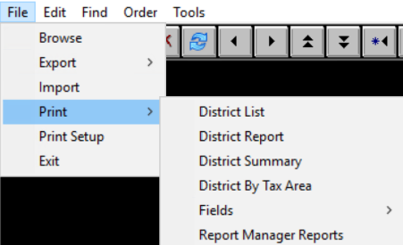

 File-Print – Report Manager Reports

Right click on the DAVReimbursment Report and then Execute

### DAV Report by Tax Area

* There is a new report to print for the DAV loss by tax area. **This will be printed from the tax district table as well.**

 File-Print – Report Manager Reports

Right click on the DAVReimbursmentTA and then Execute

### Residential Sales Form

* When printing the residential sale form on a specific account an error would surface. This has been corrected.