Contents

Weekly Changes July 1,2024 1

Assessment 1

Miscellaneous Codes 3

Reports 4

# Weekly Changes July 1,2024

## Assessment

* There is an option to print a listing for QP 9.

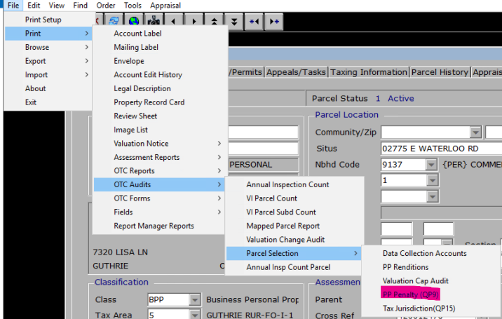

* + You will be asked for a sample size.

* + You will be asked to exclude records that have not been filed.

* + If you select Yes to exclude then each record will have a filing date on it with the heading of Filing Only – Y otherwise there will be records with no filing date and a heading of Filing Only - N.   (I checked the one with a filing date of 8-26-2024 and the appraisal record does have that filing date and an edit to go with that date.)
  + You will be asked to open the file.

* There is an option to print a listing for QP 19.

* + You will be asked for a sample size.

* + You will be asked to open the file.

* When doing subdivides if the block numbers or lot numbers were changed the legal and parcel id/cadastral id would have issues. This has been corrected.

## Miscellaneous Codes

* There is an option on the menu to report on miscellaneous code usage. This is available in the miscellaneous code table.  Select File – Print – Misc Code Usage.

## Reports

* The percent complete from the appraisal information will be on the review sheet.

