Contents

Weekly Changes Feb 13,2024 1

Assessment 1

Residential Appraisal 3

Commercial Appraisal 4

Inspections 6

Reports 9

Review Sheet 9

926P 9

# Weekly Changes Feb 13,2024

## Assessment

* Jan 1st - The filing date is included in the sale history.

* Jan 15th – There is a new menu option Tools – Recalc with Table Numbering. This will do the same thing as the recalc option however it will renumber the documents and images tables. This would be used if a mass update is done to delete a series of document or image records. This process takes longer than the recalc option.
* Jan 15th – Inspection information will be on the appraisal summary tab. This will be for all appraisal records on the account.

* Jan 15th There are some new inspection fields to query and export. These will be based on the working year on the county information table. Inspection records will be from 1-1-2023 (year before working year) to 2-1-2024 and entered will be 1-1-2023 to 3-1-2024.
  + InspectTot – The total number of inspections on an account.
  + Inspect – Will be 1 if there has been an inspection done on the account.
  + EnteredTot – The total number of entered records on an account.
  + Entrance – Will be 1 if there has been an entry done on the account.
* Jan 29th – On the interest type in the ownership table the option of Recipient has been added.

* Feb 5th – If running COV with parameters an index is created. This will be indicated right after the report is processed. Prior a refresh to inform you of this was not being done.
* Feb 5th There is a menu option to find accounts where the cross-reference tax area code does not match the tax area on the account. This could be used for personal property accounts that have a different tax area than that of the real property it is associated with. The menu option is Tools – Listing – Invalid XRef Tax Area. This is to help with Audit question 15.

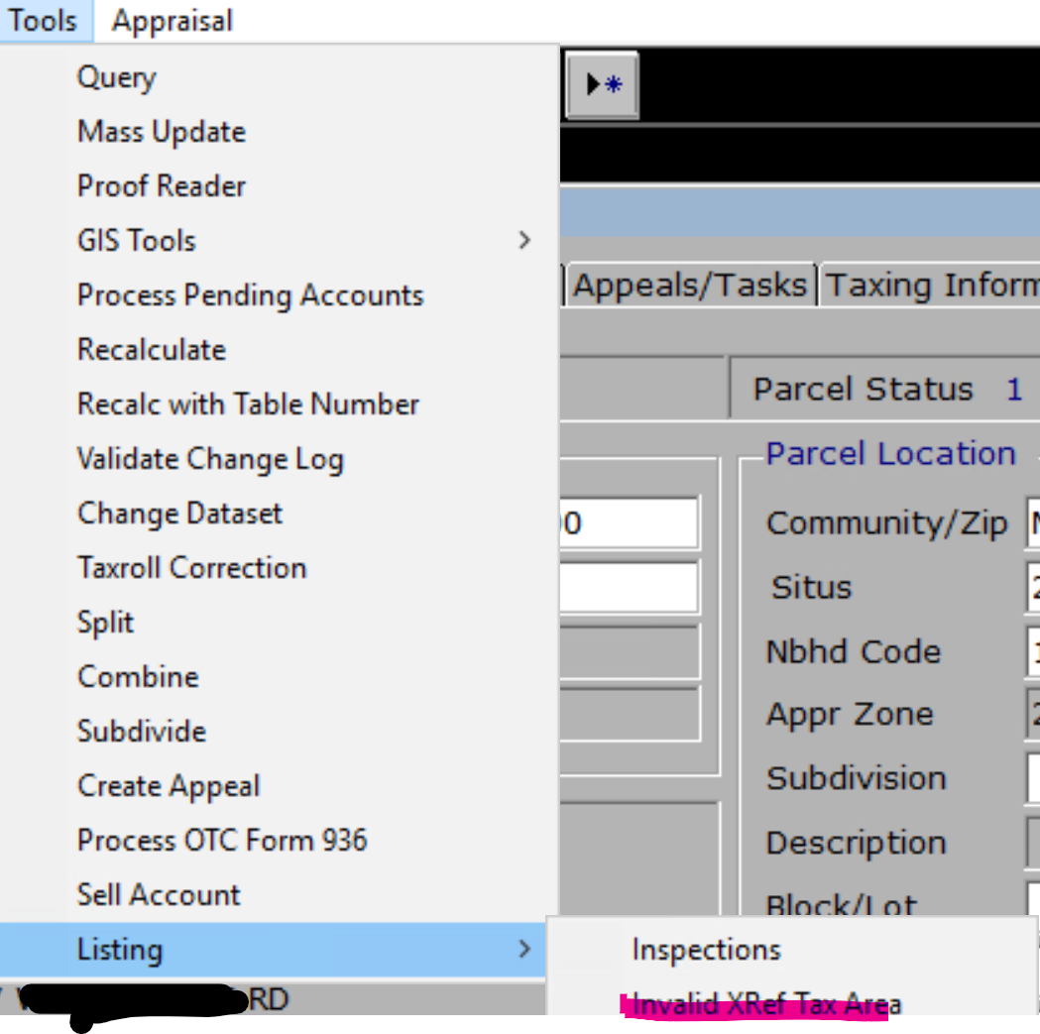

* You will be asked to run the process. While running you will get the message that the system is selecting the records.

* You will be asked to open the file if there are records. If no records, you will be informed of this. The file will be in an index of the records that are in the file.

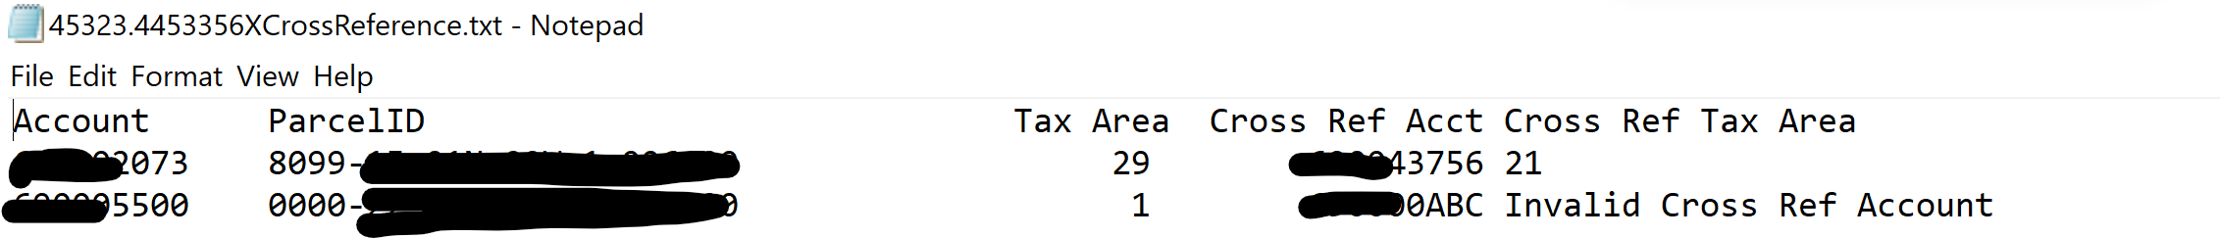

## Residential Appraisal

* Jan 1st - The filing date is included in the sale history.

* Jan 8th – Must inactive appraisal record before deleting.

* Jan 8th – The residential (ResidentialTrend), commercial (CommercialTrend), mobile home (MobileHomeTrend), and site improvement (SiteImprTrend) trend rates are on the view where they can be exported out and in indexes/queries. This is based on the neighborhood the account is in.

* Jan 15th There are some new inspection fields to query and export. These will be based on the working year on the county information table. Inspection records will be from 1-1-2023 (year before working year) to 2-1-2024 and entered will be 1-1-2023 to 3-1-2024.
  + InspectTot – The total number of inspections on an appraisal record.
  + Inspection – Will be 1 if there has been an inspection done on the appraisal record.
  + EnteredTot – The total number of entered records on an appraisal record.
  + Entrance – Will be 1 if there has been an entry done on the appraisal record.
* There is an option to get a listing of appraisal records that have not been inspected or entered. If an appraisal record has multiple of the type (inspected or entered) it will not be included in the listing/index.

You will be asked for the VI area to print for.

* You will be asked to open the file if there are records. If no records, you will be informed of this. The file will be in an index of the records that are in the file.

## Commercial Appraisal

* Jan 1st - The filing date is included in the sale history.

* Jan 8th – Must inactive appraisal record before deleting.

* Jan 8th – The residential (ResidentialTrend), commercial (CommercialTrend), mobile home (MobileHomeTrend), and site improvement (SiteImprTrend) trend rates are on the view where they can be exported out and in indexes/queries. This is based on the neighborhood the account is in.

* Jan 15th – When in edit if you clicked on the site plan table and there were no records you would receive and error. This has been correct.
* Jan 22nd – The modifier for safety deposit boxes has been corrected. Prior no value was calculated.
* Jan 15th There are some new inspection fields to query and export. These will be based on the working year on the county information table. Inspection records will be from 1-1-2023 (year before working year) to 2-1-2024 and entered will be 1-1-2023 to 3-1-2024.
  + InspectTot – The total number of inspections on an appraisal record.
  + Inspection – Will be 1 if there has been an inspection done on the appraisal record.
  + EnteredTot – The total number of entered records on an appraisal record.
  + Entrance – Will be 1 if there has been an entry done on the appraisal record.
* There is an option to get a listing of appraisal records that have not been inspected or entered. If an appraisal record has multiple of the type (inspected or entered) it will not be included in the listing/index.

You will be asked for the VI area to print for.

* You will be asked to open the file if there are records. If no records, you will be informed of this. The file will be in an index of the records that are in the file.

## Inspections

* Please keep in mind that the working year in the county information table is used to determine the inspected and entered records found. The working year for counties now is 2024 and the inspections included are from 1-1-2023 (year before working year) to 2-1-2024 and the entered records are 1-1-2023 to 3-1-2024.
* There is a query package to get the accounts in a VI Parcel Count report. (AsmntInspection) This would need to be modified to include the appraisal zone (VI Area) which is shown below.

* + VI Parcel Count Report



* There is a new report similar to the annual inspection count named Annual Insp Count Parcel. The Annual Inspection Count records all inspections and entered records in the appraisal file. If an account has multiple appraisal records that have inspection and entered records or if a single card has been inspected/entered more than once these will lead to the possibility of having an inspected or entered count greater than the number of accounts. The new report reports where an account has been inspected or entered. If there are multiple appraisal records only one of them has to have the record type as being completed.

You will be asked for the VI area to print for.

In this example 6,897 of the 6,901 records have been inspected and 6,882 of the 6,901 and been entered.

* There is a new listing option to find accounts that have not been inspected or entered.

You will be asked for the VI area to print for.

* You will be asked to open the file if there are records. If no records, you will be informed of this. The file will be in an index of the records that are in the file.

In this example you can find the 4 accounts that have not been inspected and 19 that have not been entered.

* There are similar listings (same as above except the addition of the apprid) in the residential and commercial file for individual appraisal records that have not been inspected or entered. (if an individual record has been inspected twice but entered once this will NOT be on the listing)

## Reports

### Review Sheet

* Jan 1st – There was an issue with attaching review sheets with spaces that have been corrected.
* Feb 5th – The card and building number will be in the title of the report.

### 926P

* Jan 15th – Blank lines on the name and address have been removed.