Contents

Weekly Changes Dec 18,2023 1

Assessment 1

Mobile Home Transfers (936) 2

Residential Appraisal 3

Commercial Appraisal 3

Personal Property 4

Public Login 4

Correction 4

Personal Property Schedule Items 5

Commercial Building 5

Public Service Company 5

Public Service Districts 5

Appraisal Values 5

Outbuildings 6

Miscellaneous Improvements 6

Agland 6

Entrance 6

Sketch Vectors 6

Sales 6

Reports 7

926 and 926P 7

924 7

District Summary 7

Assessment Roll 7

Ownership List 7

# Weekly Changes Dec 18,2023

## Assessment

* Dec 4th If the record is deleted this will be indicated in the account message. Other messages include pending active account, inactive account, pending inactive account, advance taxes, pending class changes, fractional ownership, linked ownership, and cross referenced account source.



* Dec 11th The property totals, millage reports, tax roll abstract will now use the net tax on the reports. Prior these reports were using the advance tax if a 936 was done on the account.
* Dec 18th The millage report will include public service when sent to spreadsheet. Prior these were the same numbers as the real property and were not included in the totals sheet.

## Mobile Home Transfers (936)

* Dec 4th There is an additional field to have the form e-mailed to the county where the mh is being moved to.
* Dec 4th The county to move to is now a drop down of the counties in the state. If moved to another state include the state and the email box will not be checked. If a valid county is entered the email field will be checked. You can uncheck if you don’t want to send an email. A screenshot of a computer

  Description automatically generated
* Dec 11th The layout of the form changed slightly.
* Dec 11th An edit log will be created when the 936 is applied. The options selected will be part of the note.
* Dec 11th There is the option in the county information table to send a copy of the email to the counties e-mail.

* Dec 11th The e-mail will not be sent within the county. Prior if the move was within the county the email would be sent twice.

## Residential Appraisal

* Dec 11th There is an account message on the file. This will include deleted records, appraisal inactive, account/appraisal inactive, pending inactive appraisal, and cross referenced account source.



* Dec 18th The appraisal files will have the message of the frozen value, homestead amount, and other exemption in the notes.



## Commercial Appraisal

* Dec 11th There is an account message on the file. This will include deleted records, appraisal inactive, account/appraisal inactive, pending inactive appraisal, and cross referenced account source.



* Dec 18th The appraisal files will have the message of the frozen value, homestead amount, and other exemption in the notes.



## Personal Property

* Dec 4th There is an account message on the file. This will include deleted records, pending inactive appraisal, account/appraisal inactive, appraisal inactive, and cross referenced account source..



* Dec 18th The appraisal files will have the message of the frozen value, homestead amount, and other exemption in the notes.



## Public Login

* Dec 18th When logging in with a public group user the private pop ups will not display. In addition the private notes will not have the note display. Private images will not have the image name or description display. In both cases the preview will not display the information. This is in all forms that have notes.

## Correction

* Dec 4th  If a correction has been applied you will not be able to edit unless it is rolled back.

## Personal Property Schedule Items

* Dec 4th There is an account message on the file. This will include deleted records, pending inactive appraisal, account/appraisal inactive, and appraisal inactive.

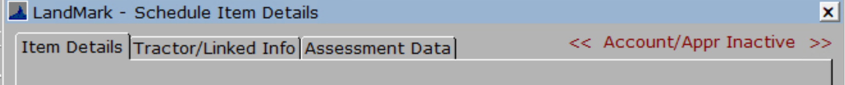

## Commercial Building

* Dec 4th There is an account message on the file. This will include deleted records, account inactive, account pending inactive, account pending active.



## Public Service Company

* Dec 4th There is an account message on the file. This will include deleted records, inactive company, pending active company, and pending inactive company.



## Public Service Districts

* Dec 4th There is an account message on the file. This will include deleted records, inactive company, pending active company, and pending inactive company.



## Appraisal Values

* Dec 11th There is an account message on the file. This will include deleted records, appraisal inactive, account/appraisal inactive, and pending inactive appraisal.



## Outbuildings

* Dec 11th There is an account message on the file. This will include deleted records, appraisal inactive, account/appraisal inactive, and pending inactive appraisal.



## Miscellaneous Improvements

* Dec 11th There is an account message on the file. This will include deleted records, appraisal inactive, account/appraisal inactive, and pending inactive appraisal.



## Agland

* Dec 11th There is an account message on the file. This will include deleted records, appraisal inactive, account/appraisal inactive, and pending inactive appraisal.



## Entrance

* Dec 11th There is an account message on the file. This will include deleted records, appraisal inactive, account/appraisal inactive, and pending inactive appraisal.



## Sketch Vectors

* Dec 11th There is an account message on the file. This will include deleted records, appraisal inactive, and pending inactive appraisal.



## Sales

* Dec 18th If using the menu option Edit – Add Account if the sale removed the cap (Included Parcels tab) and any of the account(s) are real property and do not have the cap remove flag selected you will get a message to review the accounts.

## Reports

### 926 and 926P

* Dec 18th Wording on second page about where to get 974 has changed.

### 924

* Dec 18th Slight change for tractors in part 1.

### District Summary

* Dec 4th The district summary report will have the totals and the previous year for the valuation and net tax revenue. This is printed from the district file. (File – Print – District Summary)

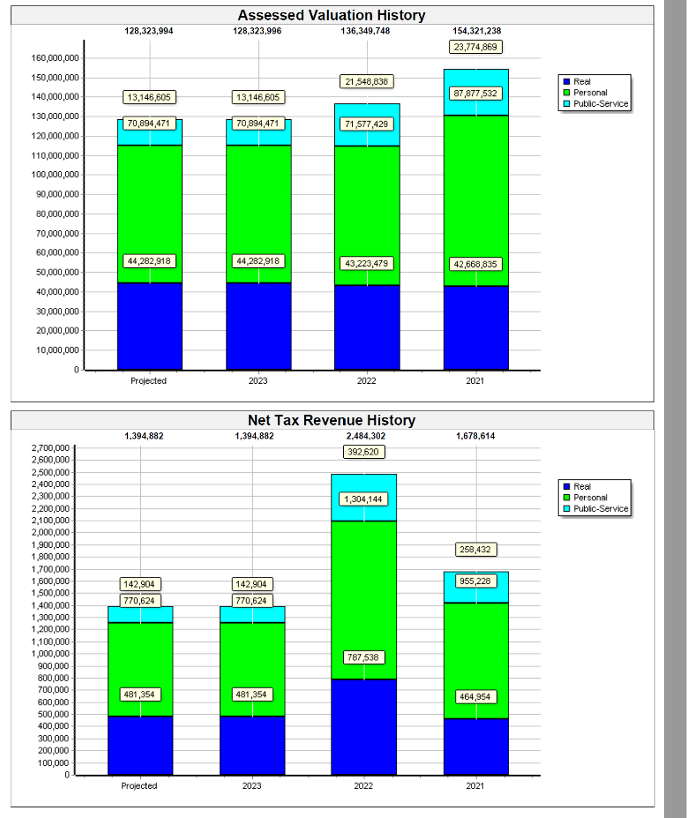

### Assessment Roll

* Dec 4th The report will have the year in the title. This is printed from the assessment file. (File – Print – Assessment Reports – Assessment Roll)

### Ownership List

* Dec 4th The report title has been updated to reflect the report that is being printed. This is printed from the assessment file. (File – Print – Assessment Reports – Ownership List)

