Contents

Weekly Changes Aug 4,2024 1

926P 1

Visible Damage 2

Lot Model 3

Sales 3

Image Viewer 3

Map Analyzer 3

Image Export 4

# Weekly Changes Aug 4,2024

## 926P

* There are menu options for the PP Valuation notice and PP Valuation Increase notice available on the assessment and personal property files. The PP Valuation notice will have “County assessor Notice of Valuation” in the title where the PP Valuation Inc Notice will have “County Assessor Notice of Increase in Valuation”. Prior to this the Notice Required check box would determine this. The Notice Required check box can continue to be used to index records to print notices.

Prior to change:

If Notice Required is checked

If not checked

## Visible Damage

* Visible damage has been added to residential and commercial building forms. The drop down will mirror the options on the review sheet. The functional depreciation has also been placed in the visible damage section of the review sheet.

Residential

Commercial Building

Review sheet

## Lot Model

* After making a change to the lot model the Apply tool will confirm you want to do this.
  + As a side note after a change to the lot model or appraisal zone is done that will affect appraisal values the Apply menu option should be selected to update the records.

## Sales

* When there is a multi owner sale and you select to not change the primary ownership id the ownership table and name on the assessment data tab will not update. This may be in a fractional owner situation where the primary owner sells a portion of their interest.

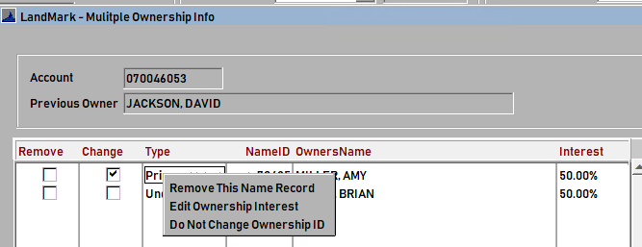

## Image Viewer

* The image viewer has the ability to code images as private.

## Map Analyzer

* The disclaimer on the map analyzer reports is located below the images.

## Image Export

* On the image export the primary assessment photo will be coded with _P at the end of the file name.

* Archived and private images will be placed in separate folders. Private and archived images will be placed in the private folder.

