June 15, 2023

2023 Cost Manual Effects on Value

We will be sending the new cost manuals next weekend where they will be available the 26th.  This will include the 2023 manuals for NBC,  Moore Precision Costs for commercial properties.  There will be some changes to the miscellaneous code costs for 2023 as well.   In addition there will be a process to come to a cost for mobile homes using NADA will be available. There will be some additional changes that I will get information to you the middle of next week.

I have evaluating the effects of the new cost manuals from the 2022 manual to the 2023 manual. I did this by taking data from May 1st of 17 counties to an independent environment. These counties data represents 28.5% of real property accounts. The average increase on real property was 10.59% and 14.31% for commercial accounts.   The commercial depreciation tables are changing to lead lower quality buildings to depreciate quicker and higher quality buildings to depreciate slower. In addition for the higher quality buildings they will have a maximum depreciation rate.   The example below is a 63 year old service station where the depreciation along will lead to a 30% increase in value if the RCN did not change where in this case there was a 21.5% increase in RCN which leads to the a 300% increase in the building. (with land being the same value in both cases this will decrease the final percentage of increase)

The miscellaneous code UTIL will have a change from the previous coding. I will provide information about this next week.

If you have any questions, please let me know.

Current Depreciation



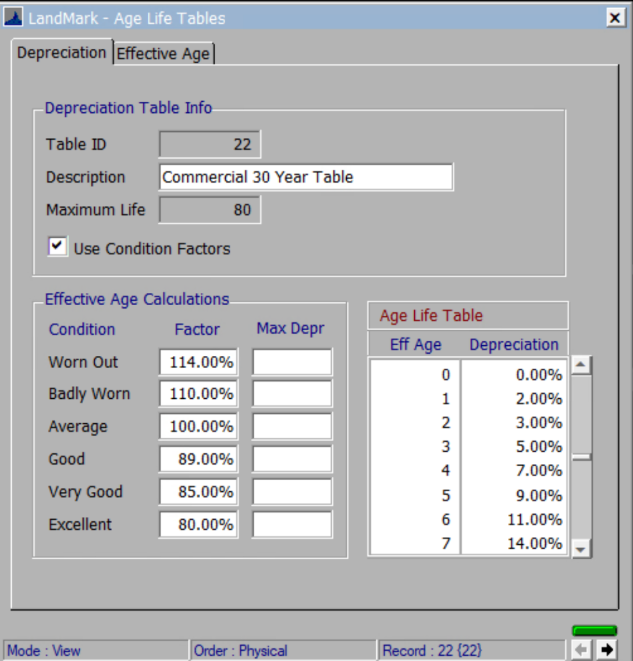

New Depreciation

