VRS 5.0 and 5.1
Testing outside of RVI in Kofax’s VRS Test Console (The RVI PC Viewer must be closed, if installed):
Go to Start, Programs, Kofax VRS, VRS Test Console. When the application opens, click ‘Select Scanner’, pick your scanner from the list then click OK. If your scanner has a
License for barcode recognition, you will need to enable barcode scanning by selecting ‘Scan Settings’ then click the barcode icon and highlight the barcode type that will be read.
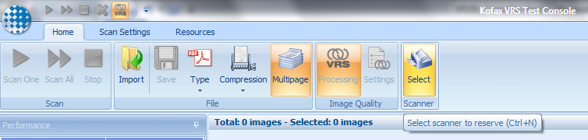
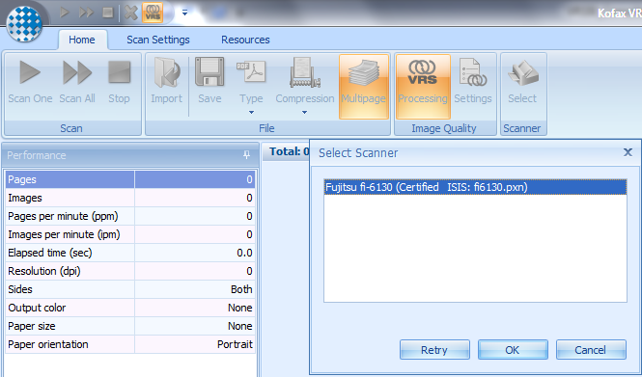

Once the scanner successfully loads, the icons at the top of the screen will be active.
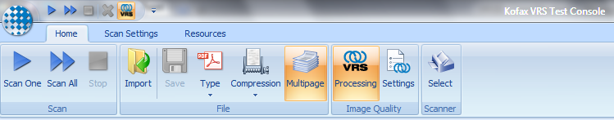
Load paper in the scanner. To scan this document, click the 2nd icon (two arrows). This will execute the scan.
The results will be displayed in a window to the left. If barcodes were read the barcode type and value will be displayed. Once the scanner is functioning in VRS Test Console, close VRS Test Console and open the RVI PC viewer. Within RVI, remember to go to Image, Preferences, Scanner Preferences (Scanner Support) to enable ‘Load Kofax Scanners’ and set your default scanner to your particular make/model.
(NOTE: If you get any licensing errors when trying to use Kofax VRS or AIPE, you will need to contact Kofax support at 949-727-1733 or provide valid license information within the VRS Administration Console, License section)
To disable the Out of Paper message use the following steps:
You can disable the out of paper message by right-clicking on the VRS icon in the system tray . You should have an option for Admin Console. When that opens, select the exceptions tab and find the entry for out of paper. Click the drop down and select ‘Return Error’ then click the SAVE button then CLOSE button. This will stop the out of paper message from popping up at scan time.
