Screen Scrape using Chrome Extension

Download and install the Chrome Extension from the website.
https://chrome.google.com/webstore/detail/real-vision-software/anadknmifjpdelofkdhfpobmlmaodpoj
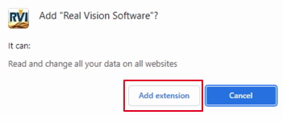
Once it is installed, go to More Tools/Extensions inside the Chrome browser.
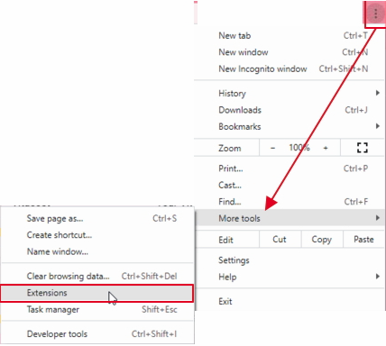
Find Real Vision Software and verify it is enabled.
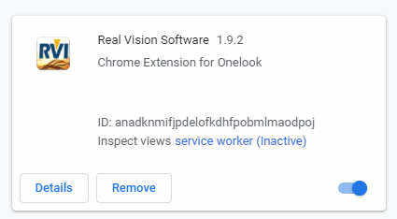
Pin the extension by clicking on the Extension icon in the top right corner of the Chrome browser.
Find Real Vision Software then click the pin icon.
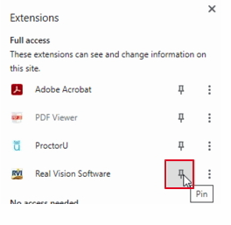
When it is properly running, you will see the RVI icon active at the top right corner of the Chrome browser.
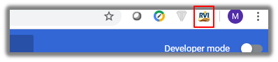
If you are running RVI 9.0 One Look, you have no other setup to do.
If you are not, you need to click on that RVI icon at the top right corner of the Chrome browser then setup 2 things.
- HTTP Address – The IBMi HTTP address including the port if needed.
- User Name – The unique internet user id for each user. (This user id must match the user id that is used to login to One Look.)
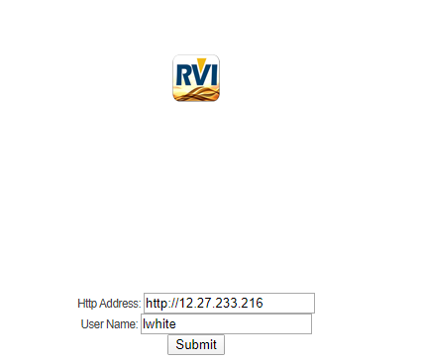
This control will send a USER.TXT file (DEVICE ID - $ in front + .TXT) to the IMAGE directory on the IBMi when the screen scrape is performed.
The file will contain the data received by the screen scrape keystrokes (CTRL+SHFT+S).
Next, the process posts to the program RVISSPCO
The SYSOVRPF values below determine the processing.
ONELOOK = Y
Means it will process the screen scrape all the way to the Onelook viewer.

ONELOOK <> Y
Means it will process the screen scrape to the RVI PC Viewer in the internet frame.

IMAGE = IMAGE DIR
The USER.TXT file will be picked up and a new xxxxxxxx-PCS.TXT file will be generated.
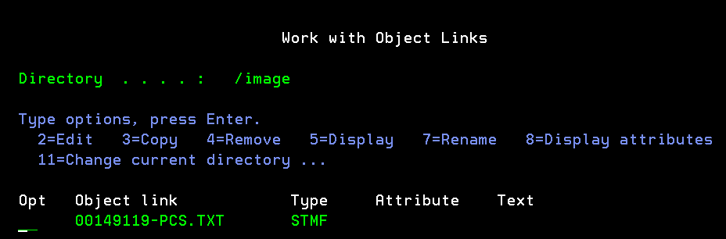
The first line of the TXT file will be the pre-scrape name
The second line of the TXT file will be the index(es) it captured.
The remaining lines of the TXT file will be the data from the screen.
