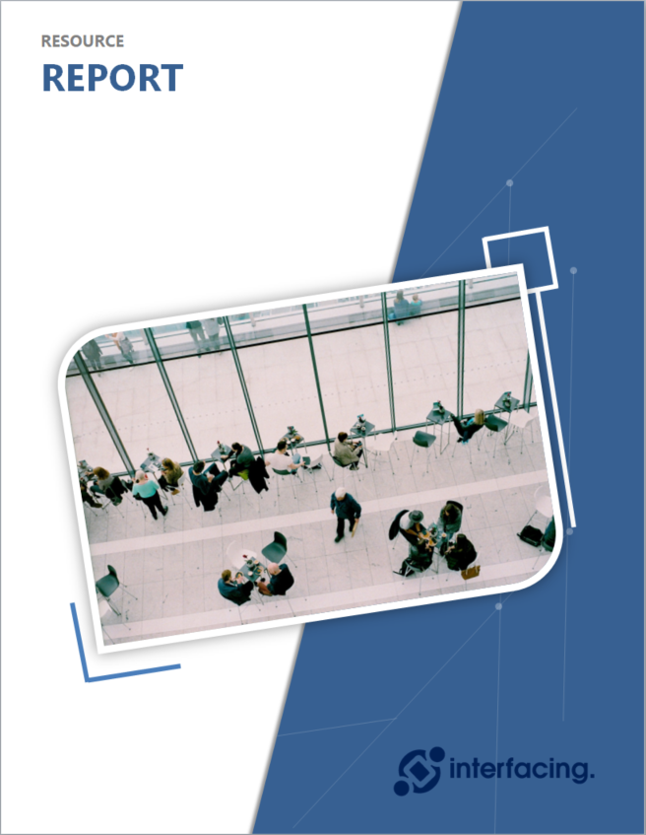
{#templaterConfig}{#subject}{#object}{name}
Version: {version}
Last Date Modified : {modificationDate}{/object}{/subject}{/templaterConfig}

{#templaterConfig}{#subject}{#object}

{name}
Description
@@richTextDescription:{nodeId}@@{/object}{/subject}{/templaterConfig}

Resource Summary
The following table is a list of Resources in the EPC with contact information and associated roles.
First Name | Last Name | Parent | E-mail | Phone Number | Roles
{#objects}{#object}{firstName} | {lastName} | {#parent}{name}{/parent} | {email} | {^phone}N/A{/phone}{#phone}{phone}{/phone} | {^roles}N/A{/roles}{#roles}{#target} ● {name}  {/target}{/roles}{/object}{/objects}

