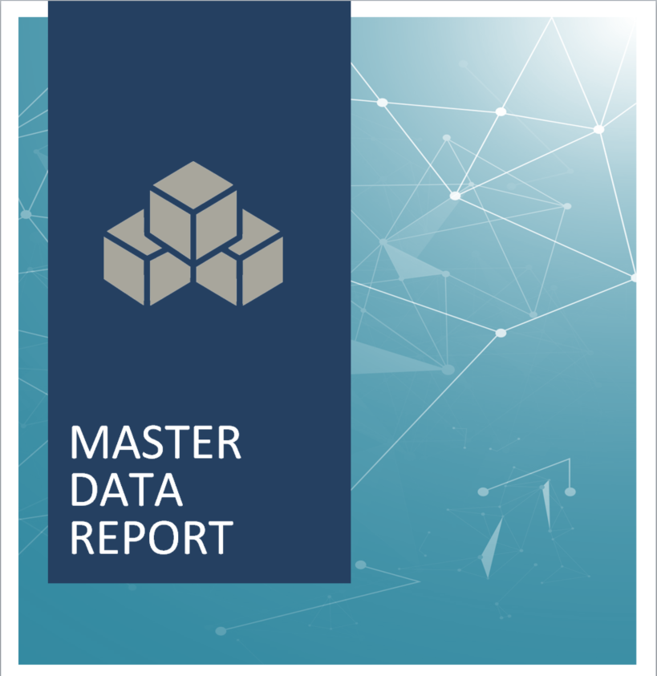

{#templaterConfig}{#subject}{#object}{name}

Version {version}
Last Date Modified {modificationDate}{/object}{/subject}{/templaterConfig}

Master Data Report
The following document is a report of Master Data Entities displayed in a tabular format.
Entity | Owner(s) | System(s) | Attributes | Processes (CRUD) | Tasks (CRUD) | UDAs* (Name [Value(s)])
{#objects}{#object}{name} | {#roles}{#target}{name}  {/target}{/roles} | {#assets}{#target}{name}  {/target}{/assets} | {#attributes}{#target}{name}  {/target}{/attributes}{/object} | {#impact}{#processes}{name}  {/processes}{/impact} | {#impact}{#flowObjects}{name}  {/flowObjects}{/impact} | {#properties}{attributeName} :{#attributeValueText}{attributeValueText}{/attributeValueText}{#listItems}{name}, {/listItems}  {/properties}{/objects}

*UDA = User Defined Attributes

