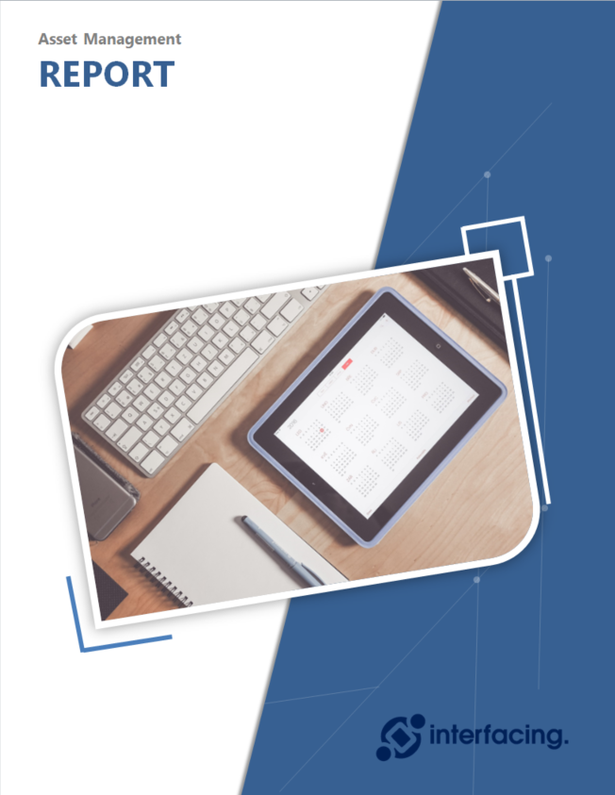
{#templaterConfig}{#subject}{#object}{name}
Version: {version}
Last Modified: {modificationDate}
{/object}{/subject}{/templaterConfig}

Asset Report
The following document is a report on Assets in the EPC.
Asset | Owner(s) | Documents | Business Rules | Entities | Attributes | UDAs*
{#objects}{#object}{name} | {#roles}{#target}{name}  {/target}{/roles} | {#documents}{#target}{name}  {/target}{/documents} | {#rules}{#target}{name}  {/target}{/rules}{/object} | {#impact}{#entities}{name}  {/entities}{/impact} | {#impact}{#attributes}{name}  {/attributes}{/impact} | {#properties}{attributeName} :{#attributeValueText}{attributeValueText}{/attributeValueText}{#listItems}{name}, {/listItems}  {/properties}{/objects}

*UDA = User Defined Attributes

