Hazardous Waste Management Checklist | Done
All hazardous waste streams generated have been identified and appropriately separated from regular wastes. | □
All applicable environmental permits relating to hazardous waste generation and disposal have been obtained. | □
Hazardous wastes are being collected by a fully licensed waste handler and records (i.e. waste manifests) disposal are fully maintained on-site. | □
Hazardous wastes are being stored in areas that have all required safety features and protections including:  - Impervious surfaces and secondary containment.  - Proper signage and labels on all waste containers.  - Protection measures from fire risks.  - Area is well ventilated.  - Wastes are protection from direct sunlight or other weather conditions.  - Only authorized persons are able to access storage areas.  - Spill clean-up equipment is readily available.  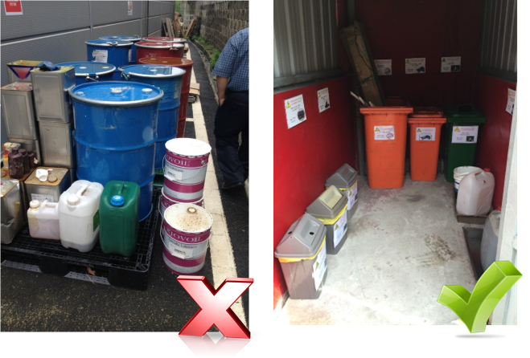 | □
Workers required to handle hazardous wastes are wearing the appropriate PPE. | □
An emergency shower and/or eyewash station is located near the location hazardous wastes are being handled. | □

