Activity: Hazard Assessment and Control - Case Study Problem

“The opposite of a problem would likely be the correct solution.”
― Joey Lawsin
Factory ABC produces a shoe with two parts that must be bonded together using an industrial adhesive. Workers apply a coat of adhesive to both parts with a brush. Once coated with adhesive the two parts are pressed together and placed on a belt that goes through an oven for curing.
Additional Background Information:

- Twenty operators have been trained to conduct this operations. They all work a single day shift, 0800 – 1600 hours with a 30-minute break for lunch. The majority of the workers also work 2 hours of overtime 3 times per week.
- Operators wear a basic uniform provided by the factory.
- Workers site during the process of gluing and placing footwear on the belt.
- The adhesive contains the following chemicals.

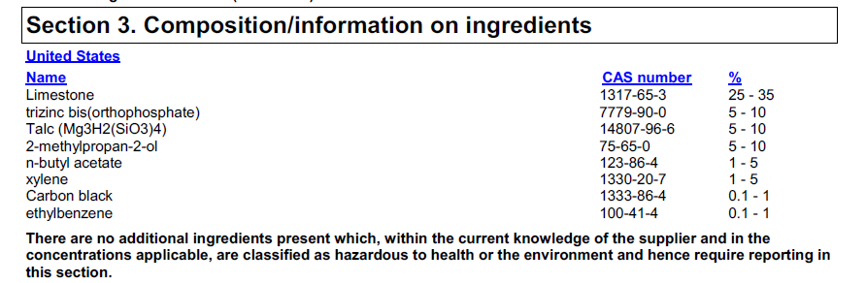

- Procedures describing how this task should be performed are not available.

Instructions: For the scenario above, identify all sources of chemical exposure to all workers and develop an assessment and control strategy (or strategies) to measure and minimize the overall exposure of workers.
Think about:
- What additional information you might need?
- What are the primary concerns?
- If you plan to conduct any assessment, how would you do this?
- How will you determine any needed controls?
- What controls will be necessary?

